

Explore The World

Submitted By: Team 10

Aravind Sheri

Sharath Koppu

Aditya Soman

Banu Sudheer

**Github Link:** <https://github.com/sharathk91/Team10ASEProject/wiki/ASE-Team10:-Project-%23Iteration3>

**Project Goal and Objectives:**

**Motivation:**

Traveling the world or visiting an unknown place is always exiting and very refreshing, because of the various local languages communication is the primary problem and traveling is very hard and it makes life difficult over there. Our Application provides a medium to communicate in any language and various other functionalities to make a tourists life easy.

**Significance/uniqueness:**

This Application has the important functionality so called a medium to communicate with local people through text to text conversion and text to speech conversion. In this application Augmented reality is used to convert any image text to normal text and navigation is very easy so that it wouldn’t be any difficulty in navigating the world.

**Objective:**

Our Application will reduce the various barriers of a tourist to travel around the world and it will run on any platform to make life easy.

**System Features (Added Features):**

* Application has the main feature as language translation that is either text from user language to text of local language of various regions.
* User can register or sign in using username and password which are stored in firebase storage.
* User can register using login page where user should provide username and password and the user details will be stored in firebase.
* The main feature of our application is to translate the text that is entered by the tourist in the native language and translate the text entered to local language where tourist visited so that communication will not be a barrier.
* Tourist using the application can locate his position using the maps in the application and use to navigate to various positions.
* Another important feature of the application is to extract the data from an image so that tourist can take a photo of a text using his phone and provide the photo as input and extract the data that is editable.
* Another cool feature in the application is image analysis which is very much useful in understanding various traffic signals in various remote areas that are pretty much different and get insights from various images.
* To over come the barrier of communicating with the local people where they cannot read we added a feature to convert the translated text into voice so that it is easy and understandable to the local people.

**First Increment Report:**

**Services and API Used:**

* IBM Text to Text language translation.
* Google API for user sign in.

**Detail Design of Features:**

**Wireframes and Mockups:**

**Below are the screenshots for the wireframes and Mockups:**

1. **Login Page for Explore World Application.**

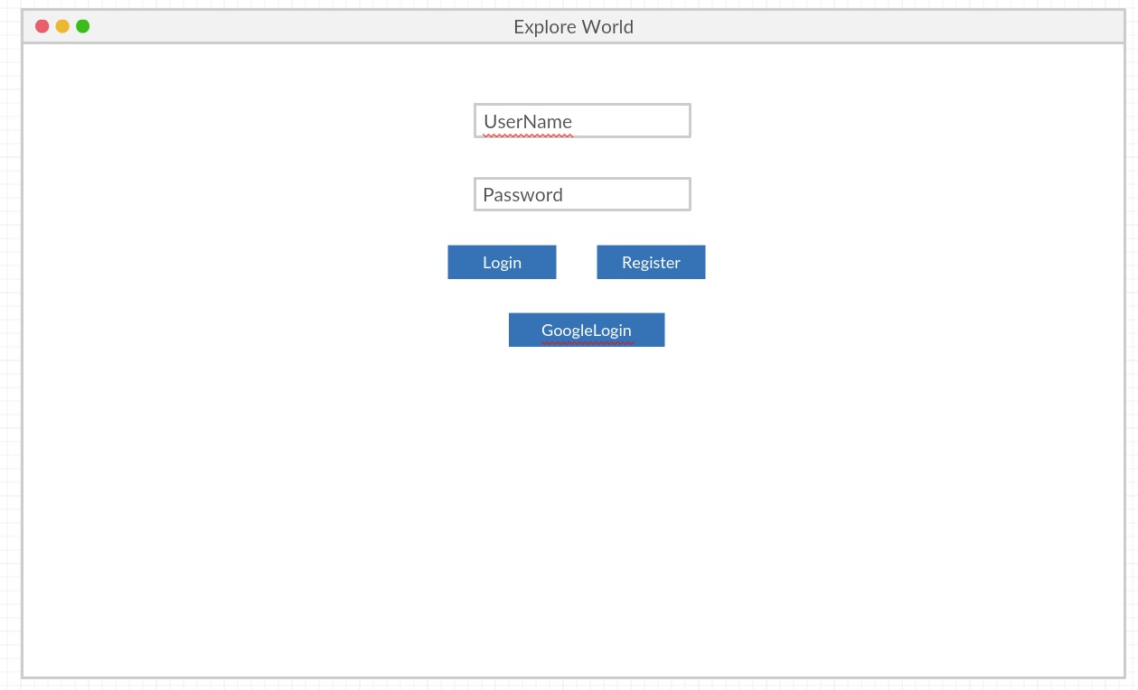

1. **Register Page.**

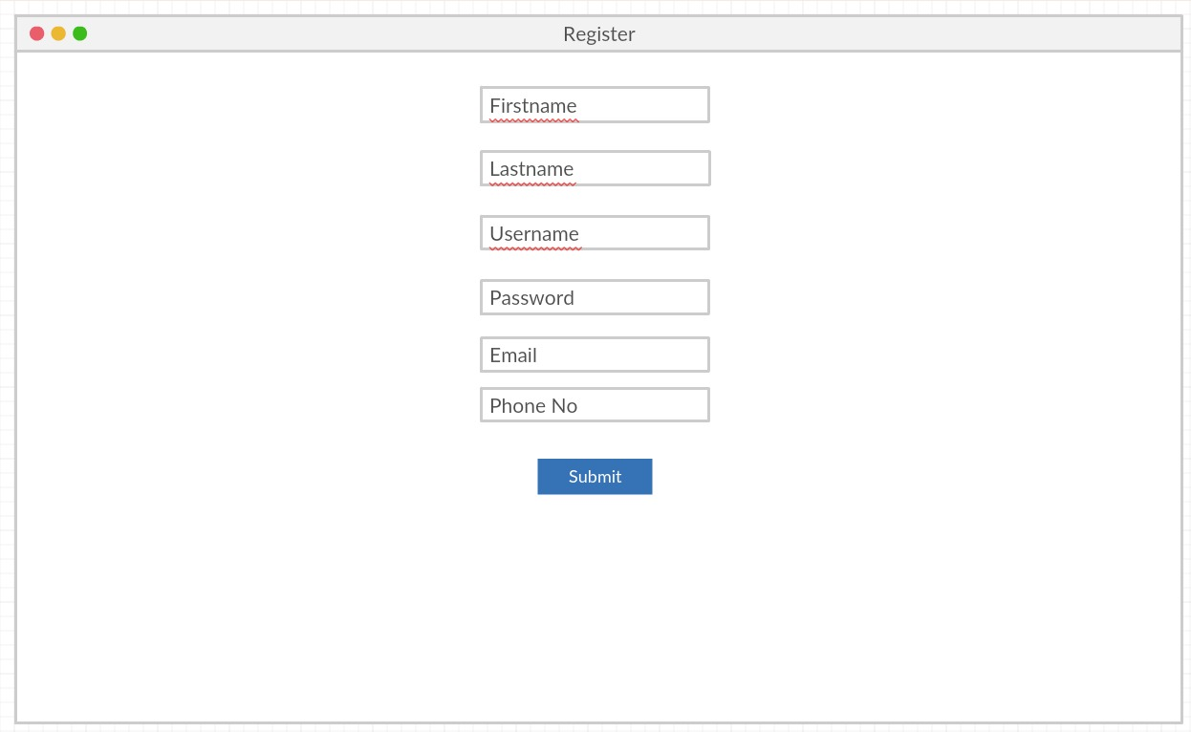

1. **Translation Page.**

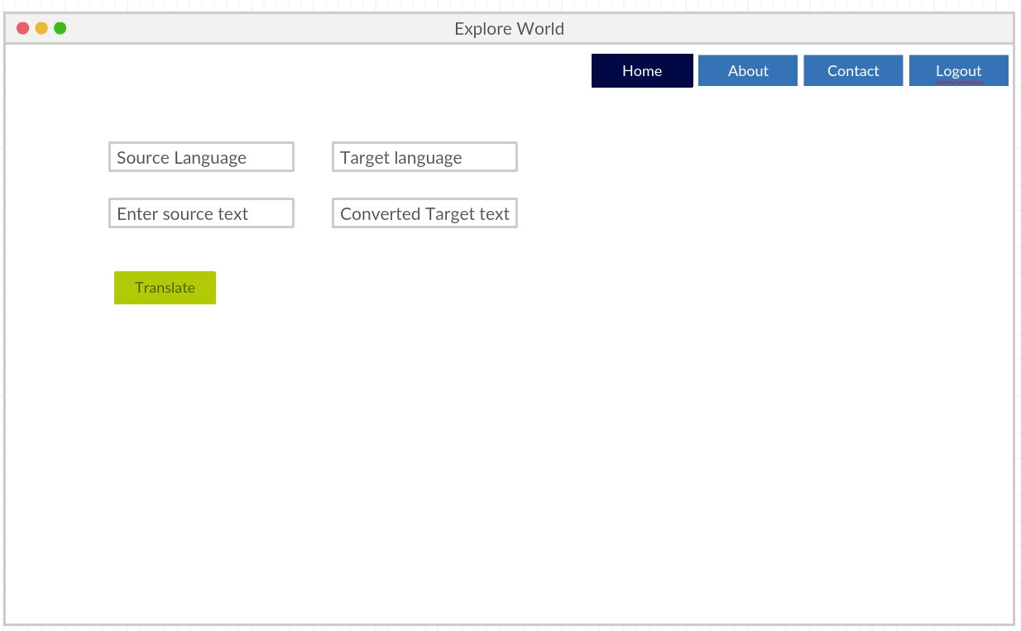

**Architecture Diagrams:**

1. **Class Diagram**

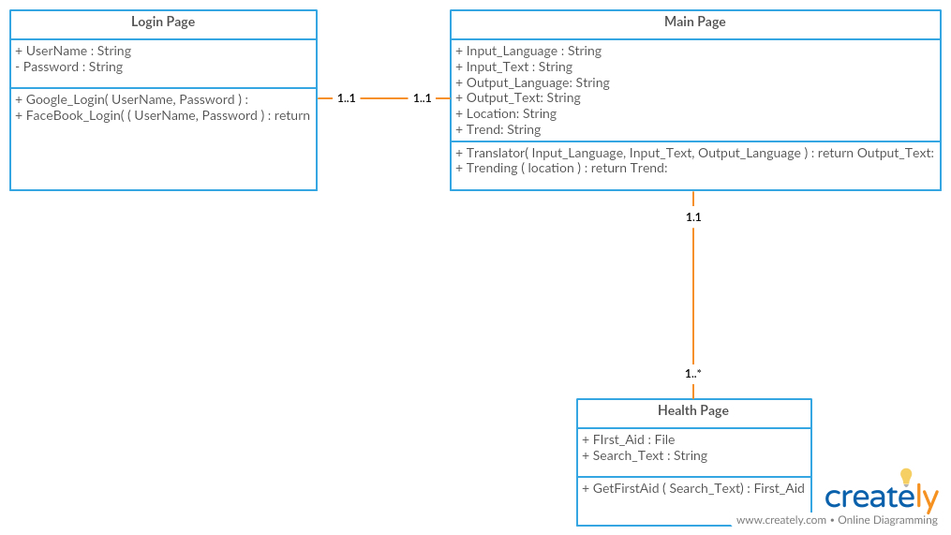

1. **Sequence Diagram**

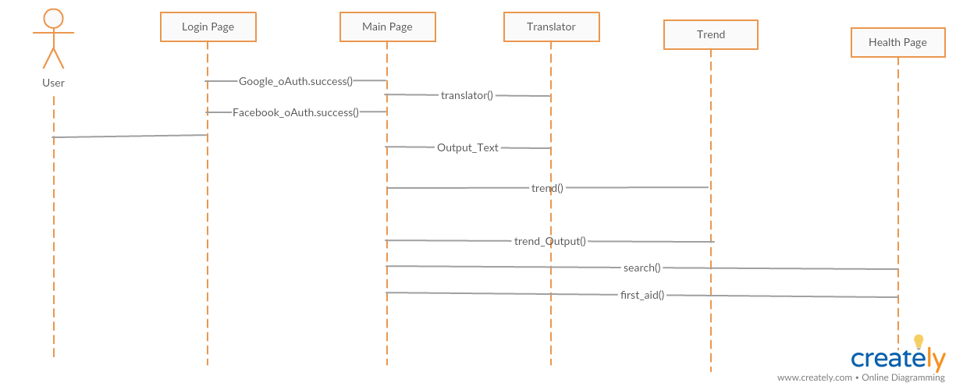

1. **Architecture Diagram**

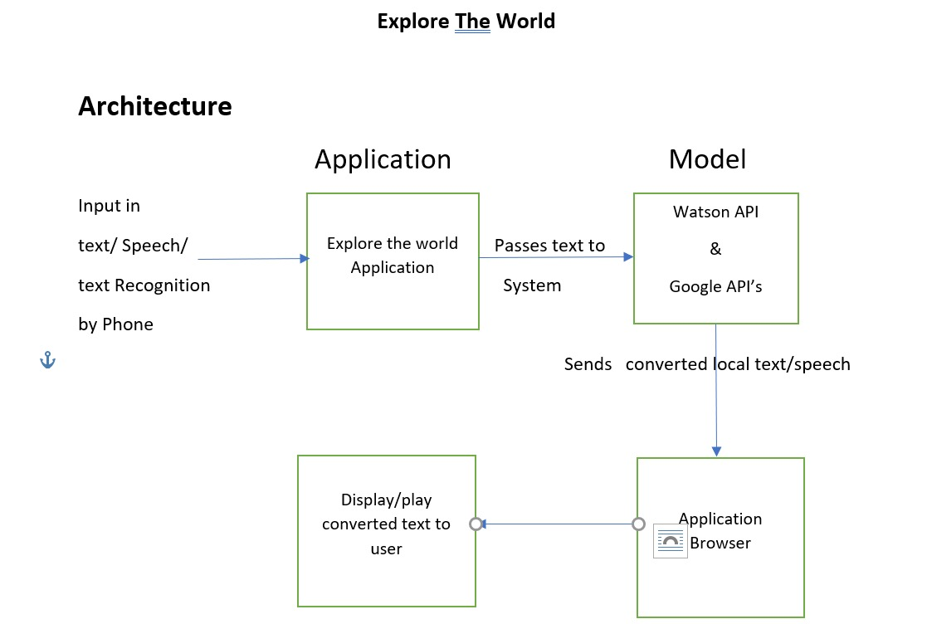

**Testing:** Tested the application with the below use cases.

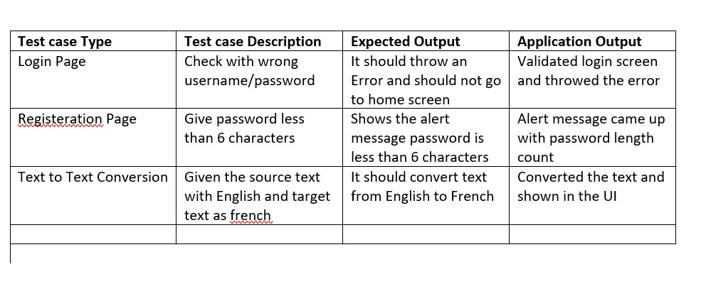

**Implementation:**

Created application in WebStorm which has login page and registration page where user can register to use the services provided in the application and also used Google API for sign of user with ease and IBM text to text language conversion. Below are the steps involved in creating the application.

1. Created a project in WebStorm and created Google and IBM text to text language conversion API keys so that we can use in the project to use various services.

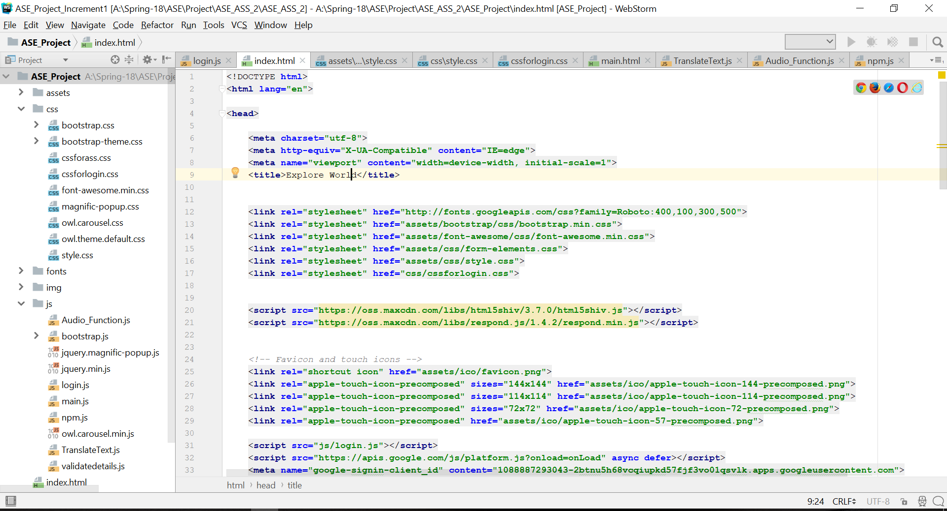

1. Created a login page for the user to login and use the various services provided in the application.

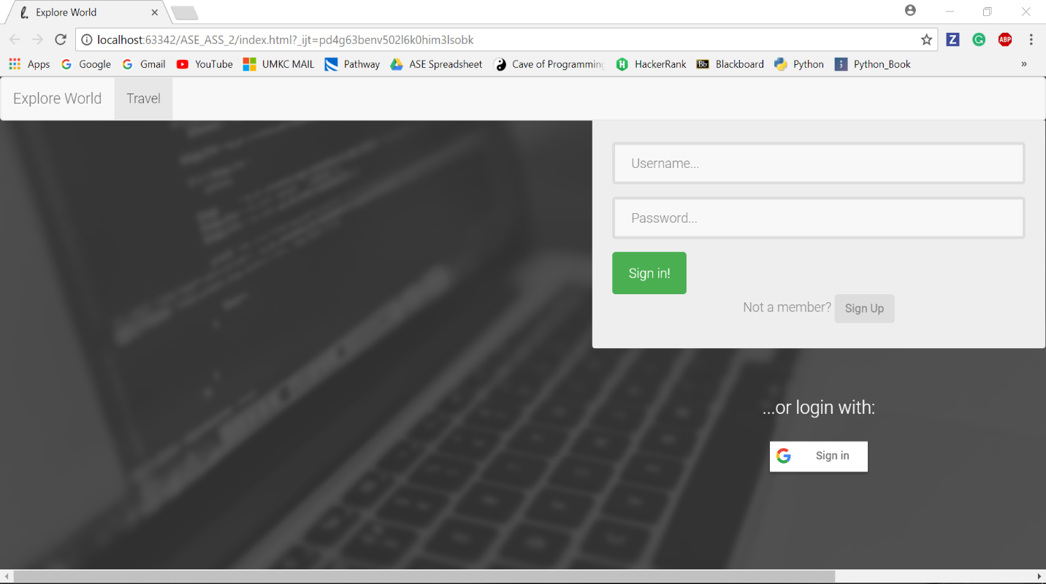

1. If the use is new to the application or never used the application he should register using registration page or user can login using Google account.

Registration Page:

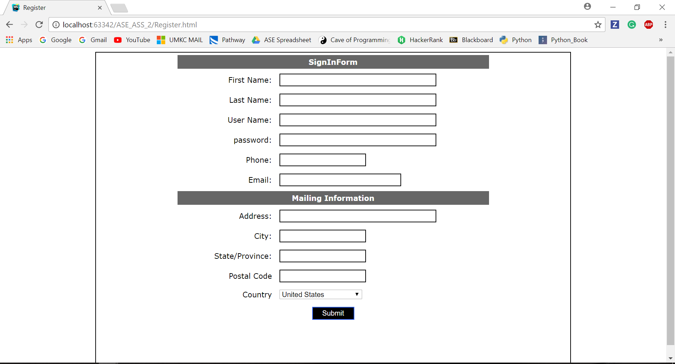

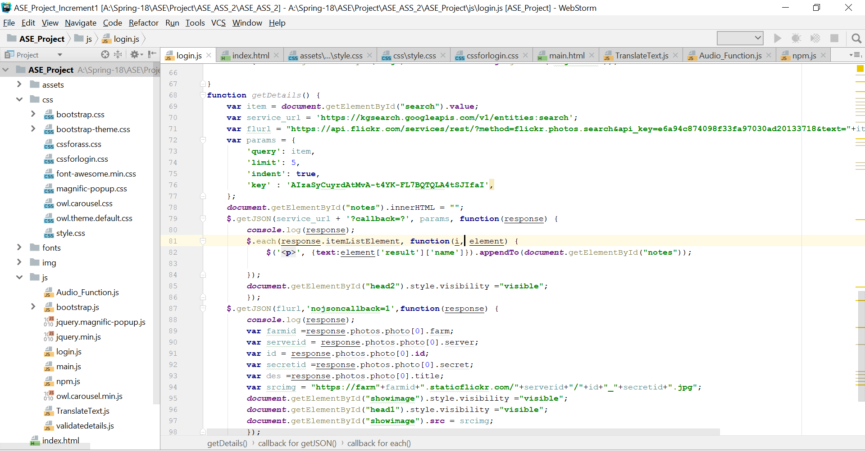

Google Login:

We used Google API for using login into the application using Google username and password to make life easy.

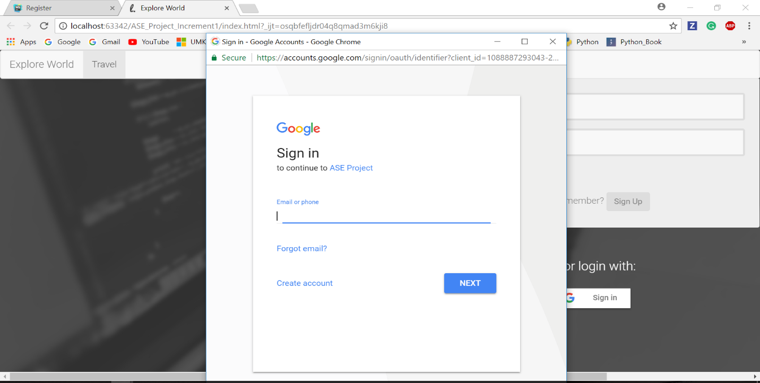

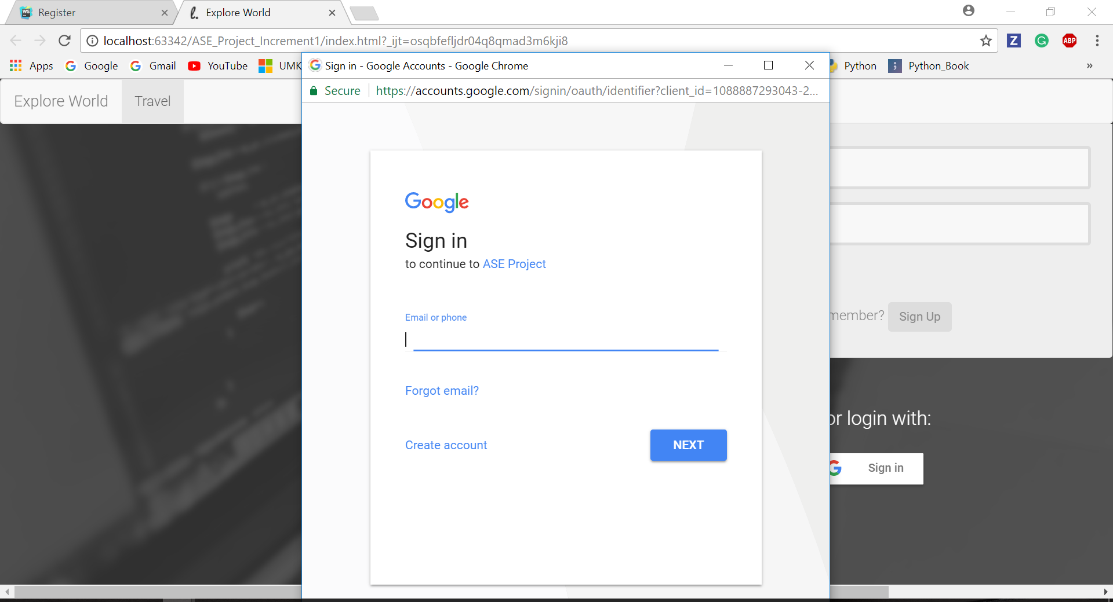

1. After user login into the application he can use all the services that are available in the application. After login the user will redirects to the main page where user has to select language drop down to enter the text and the language he wants to translate the entered text.

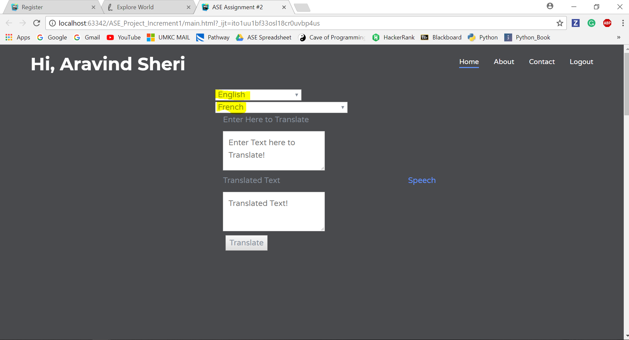

1. After selecting the languages user will enter the translate button to translate the text which he selected do that the local people can read and understand the situation or the intent of tourist is trying to explain. The text boxes will expand automatically as the user enters the text so that it wouldn’t be confusing for both of them.

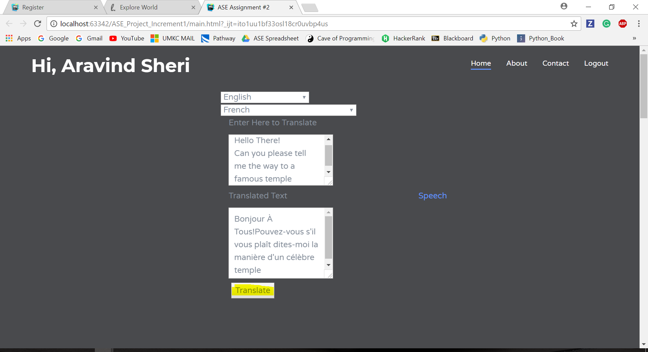

1. User can contact for any technical help using contact tab and if he wants to know more details of the application and the details of the development he can use the About tab.
2. After the use of various services in the application user can logout ang he will be redirected to the login page so that he can login again if he wants to.

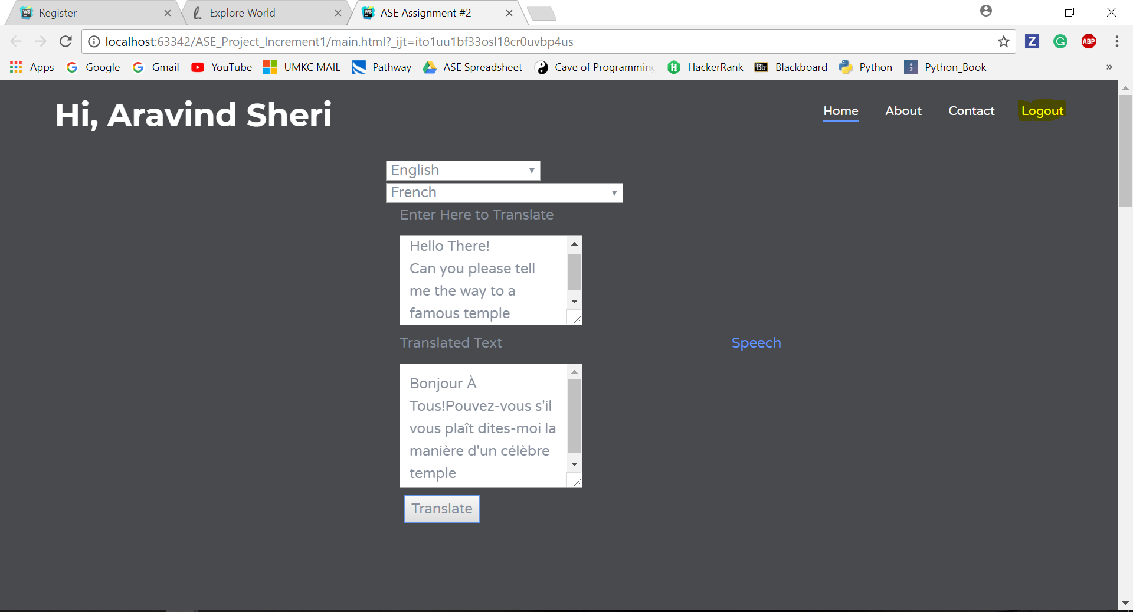

1. User will be redirected to login page after the logout.

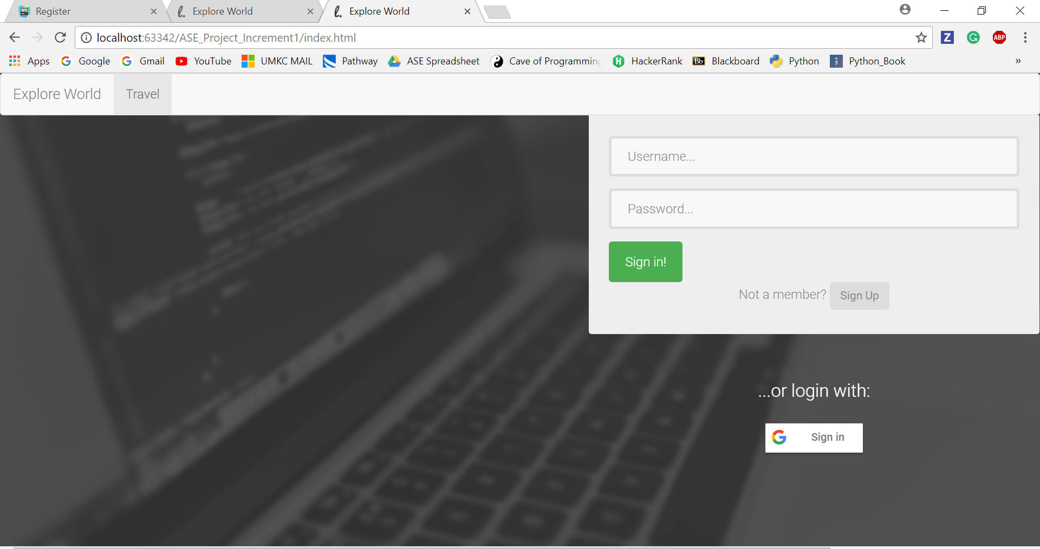

**Project Management:**

**Implementation Status Report:**

**Work Completed:**

1. **Login Page** – Login Page is the first page of the application where user will be able to login with his username and password and if the user is new to the application he can register with register page or he can login using Google.

**Responsibility and Time Taken:**

* Aditya – Designed the Login Page (5 days)
* Sharath - Implemented the login page (8 days)
* Bhanu – Tested the login page (5 days)

1. **Registration Page –** New Users will be able to register using the register page where he will he should enter the various details and the basic validations are performed using JavaScript.

**Responsibility and Time Taken:**

* Aravind– Design and Implementation of the registration page (5 days)
* Bhanu – Tested the registration page with use cases (5 days)

1. **Text to Text Language Translation:** User will selects the source language where he enters the text in the source language selected and he will select the language in which the entered text to be converted.

**Responsibility and Time Taken:**

* Aravind– Design, Implementation and Testing of the translation page (5 days).

1. **Architecture and Wireframe Diagrams**: Describes the various functionality of the application.

**Responsibility and Time Taken:**

* Sharath – Designed wireframes, architecture and blueprint of the project (5 days).

1. **Class and Sequence Diagrams: Explains the functionality of the application.**

* Aditya - Designed the class and sequence diagrams.

**Sprint Burn Down Chart:**

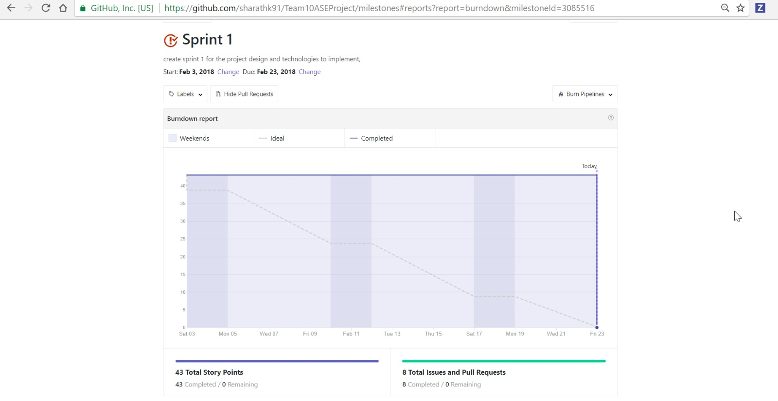

**Second Increment Report:**

**Services and API Used:**

* Yandex API for Text to Text language translation.
* Firebase for storing the details of the user and email authentication.
* OCR plugin for extracting text from image.
* Google maps API for maps and user location and navigation.
* Geolocation for getting the user current location.
* Clarifai for visual detection and getting insights from an image.
* Google API for text to speech of the translated text.

**Detail Design of Features:**

**Wireframes and Mockups:**

**Below are the screenshots for the wireframes and Mockups:**

1. **Home Page**

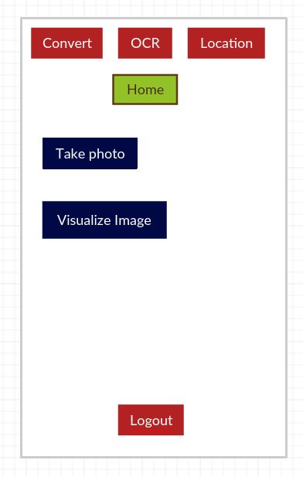

1. **OCR Plugin:**

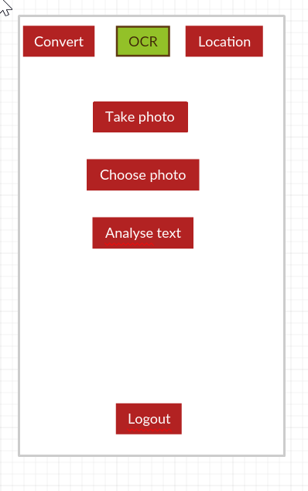

1. **Language Conversion:**

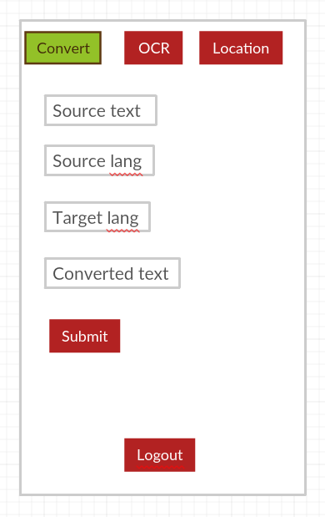

1. **Maps:**

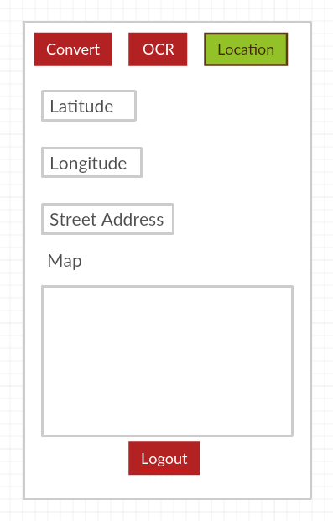

**Architecture Diagrams:**

1. **Class Diagram:**

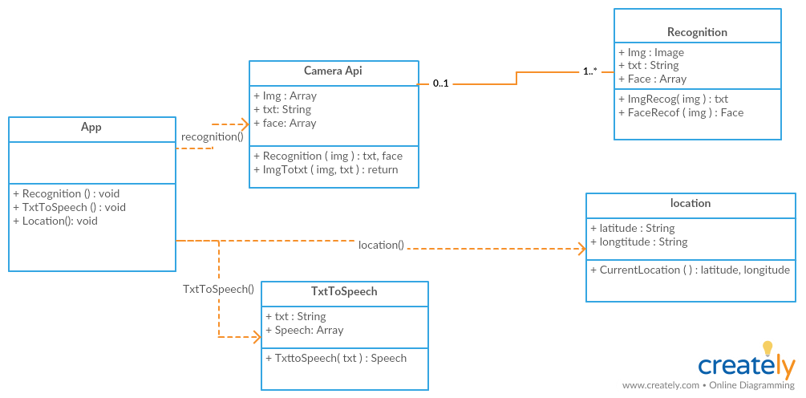

1. **Sequence Diagram:**

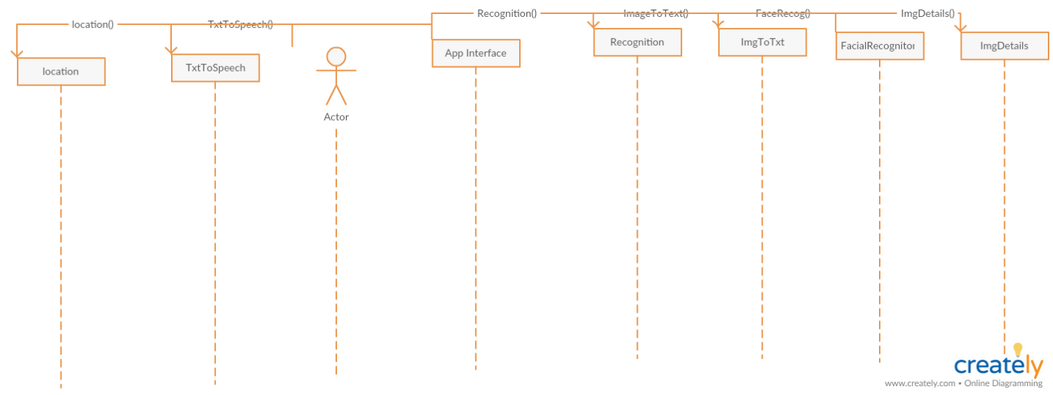

1. **Iteration-2 Architecture Diagram:**

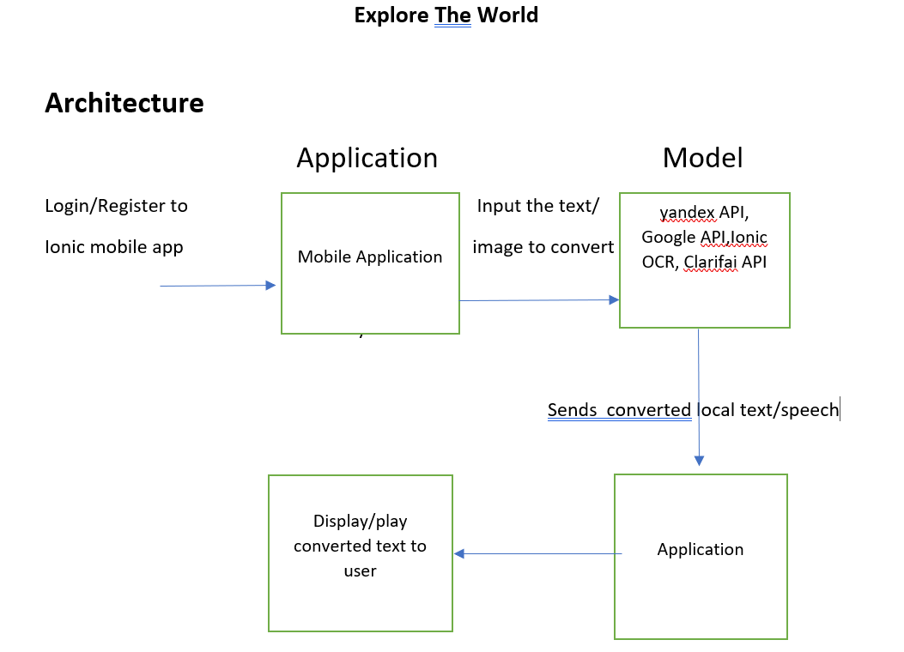

**Implementation:**

Created an application using Ionic framework so that the application is runnable in any platform and user friendly. Application has a login page where user will be able to login and use the services provided in the application and user will be able to register and the details are stored in Firebase and email authentication is used for logging into the application.

After login into the application tourist will be able to use various services like text to text translation, image prediction, Google Maps and text to speech.

1. **Login Screen:**

User will be able to login into the application using email authentication provided by Firebase API.

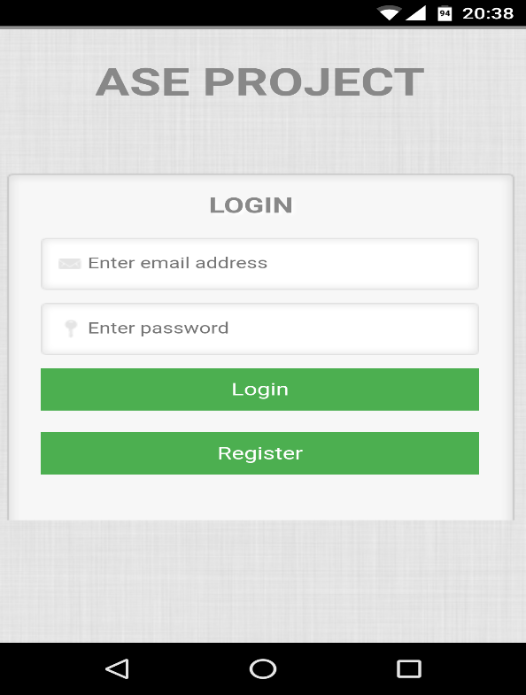

1. **Registration Screen:**

Registration of a user is done by using by the same login screen, when user provides email and password and clicks register the details will be saved in the Firebase database and the data is fetched when user logins using the email and password set at the time of registration.

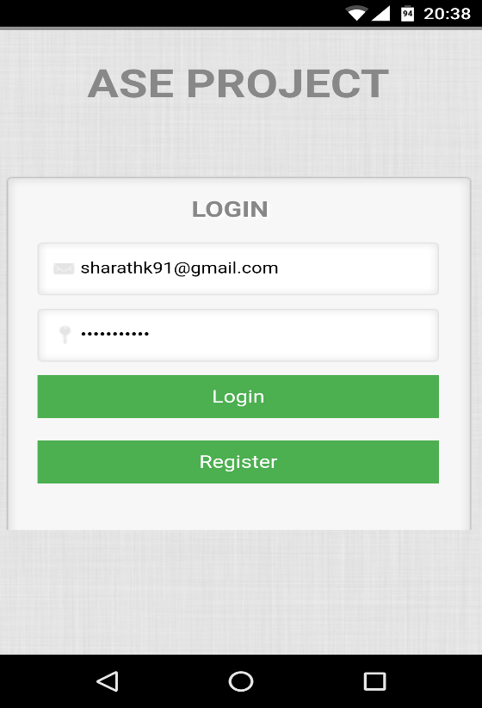

1. **Home Page:**

Home Page contains all the services of the application and tourist can use all the services that are required.

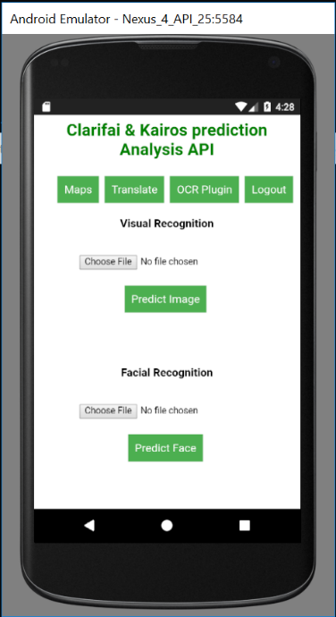

1. **OCR Plugin:**

**OCR plugin is used to extract text from an image so that tourist can take a picture of an image and convert the text in the image to editable text. User can take a picture using camera of the device and select an existing image so that he can extract meaningful text from the image.**

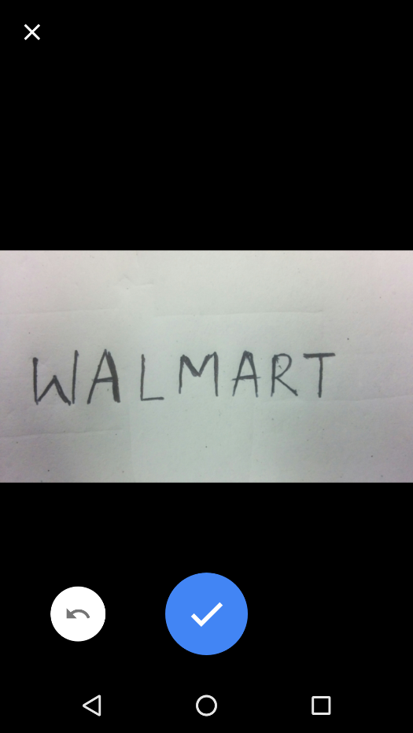

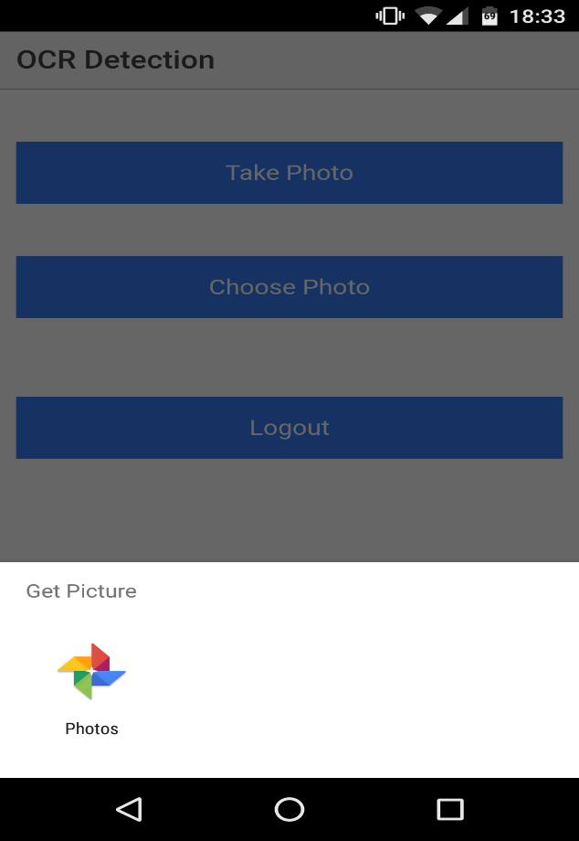

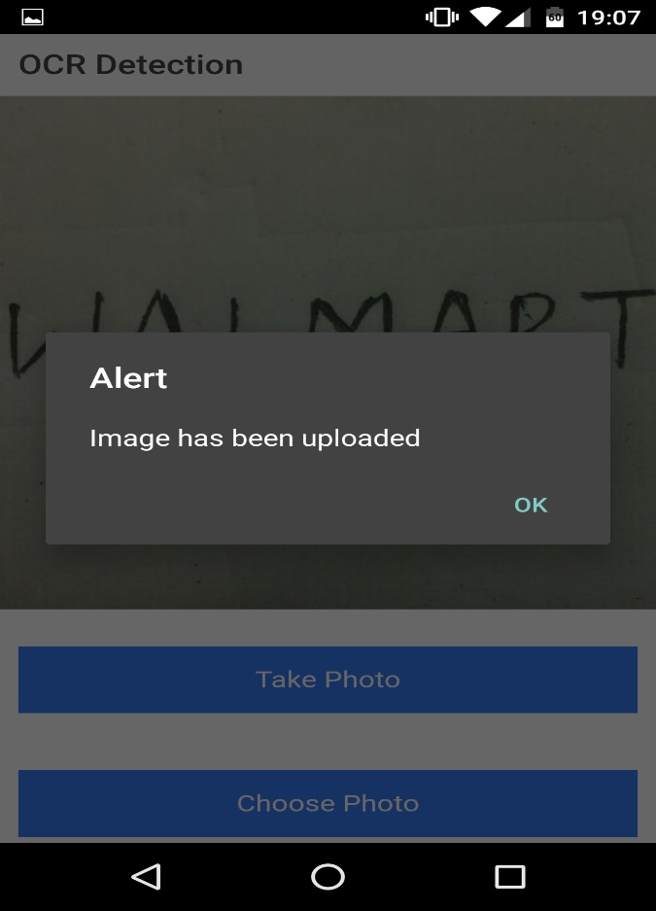

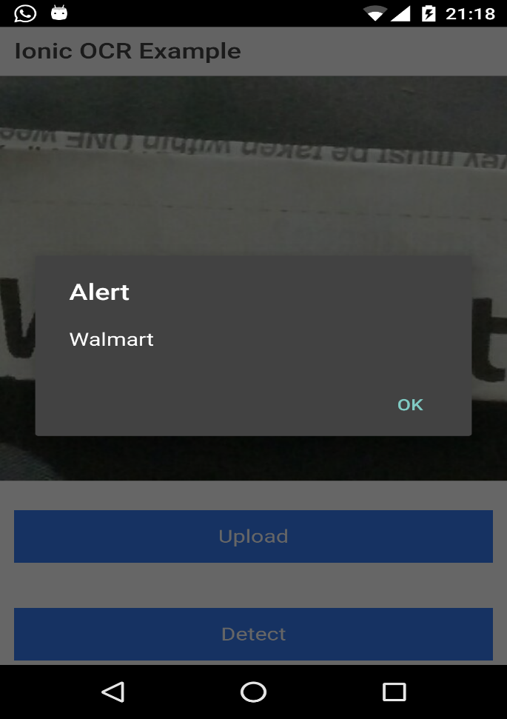

1. **Visual Recognition:**

Visual Recognition is used to get meaningful insights from an image so that tourist will be able to get useful data from an image like a traffic signal which would be useful for better understanding of various situations. User has to choose a file from the device so that he can get insights from the image.

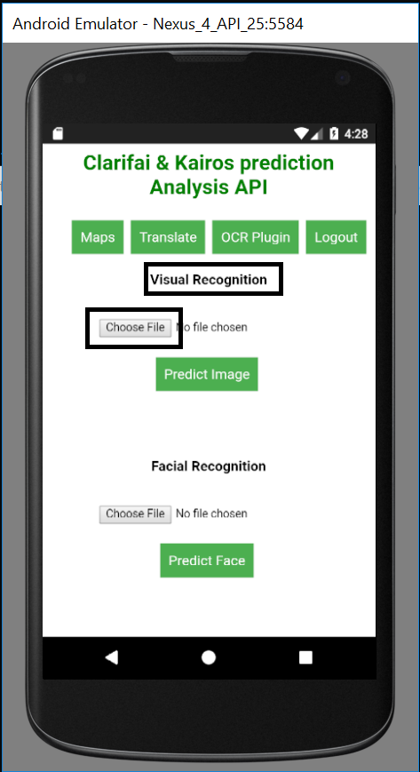

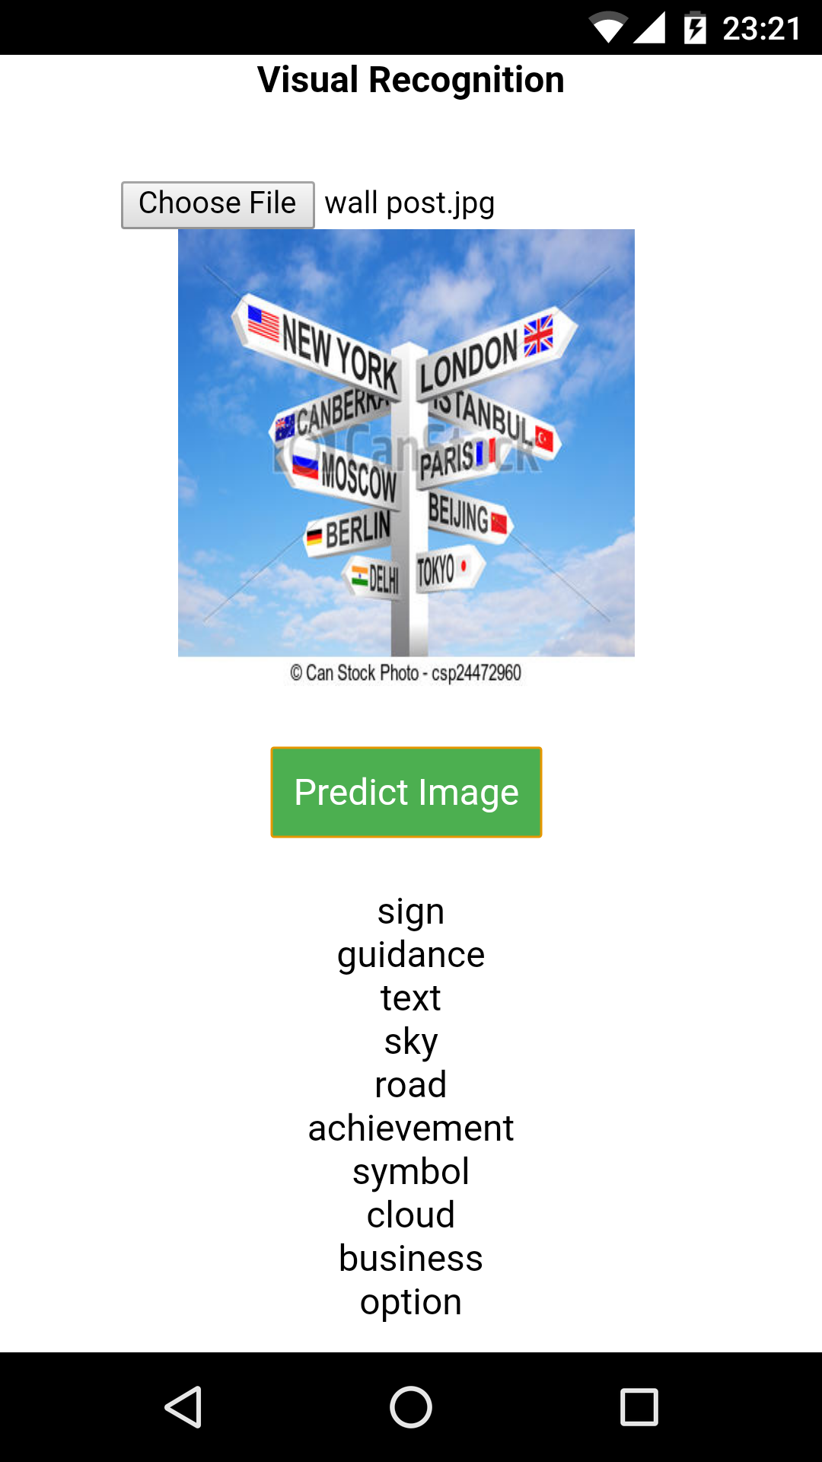

1. **Translation:**

This tab is used to translate the text from tourist native language to the preferred language so that the barrier of communication can be overcome with this service in the application.

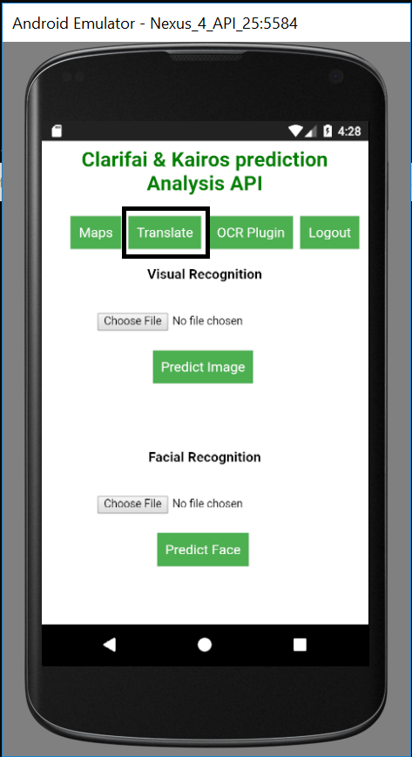

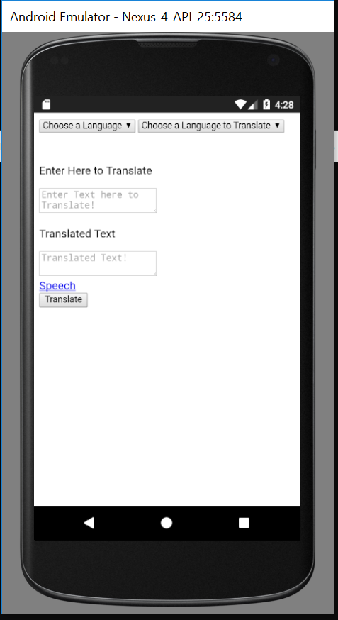

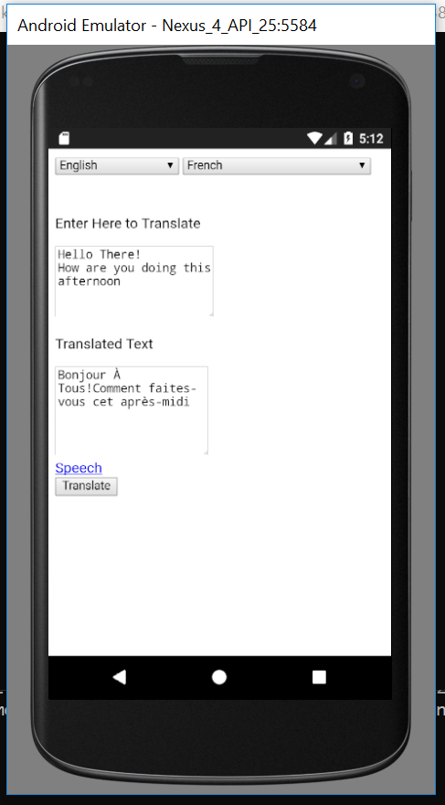

1. **Maps:**

Maps is used to locate the location of the tourist so that he can find and track the movements without opening any other application for his location.

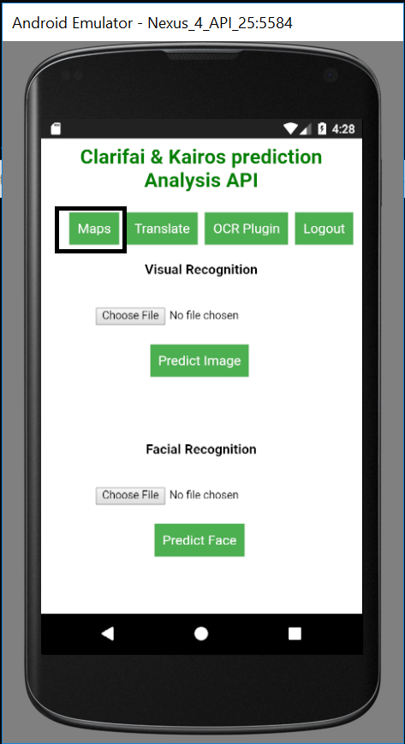

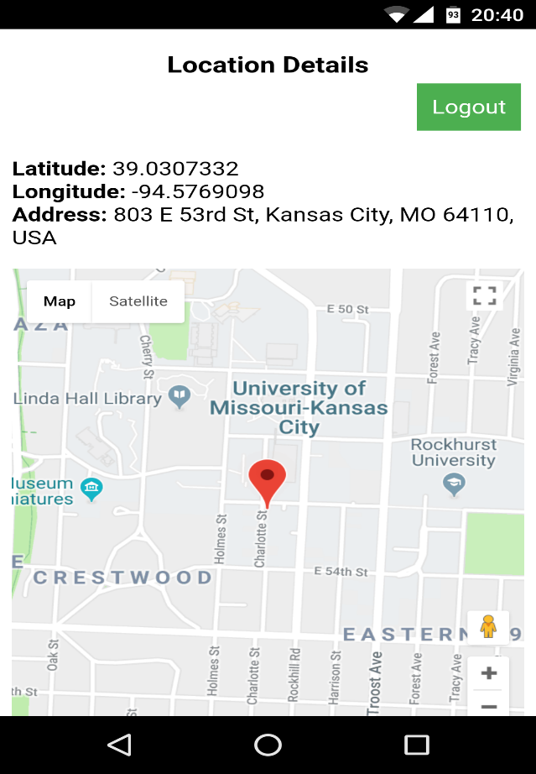

1. **Speech:**

Speech tab is used to translate the text that is translated so that the local people can understand.

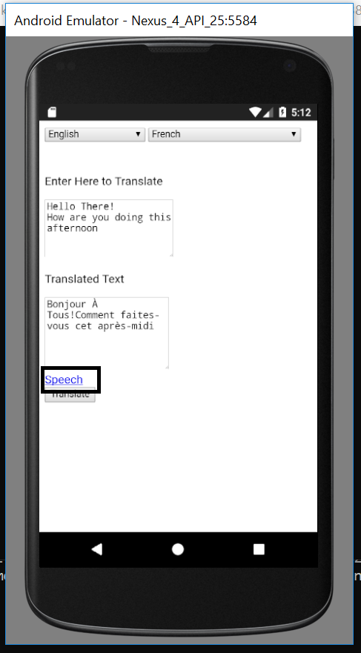

**Project Management:**

**Implementation Status Report:**

**Work Completed:**

1. **Login Page** – Login Page is the first page of the application where user will be able to login with his username and password and if the user is new to the application he can register with Firebase email authentication.

**Responsibility and Time Taken:**

* Aditya – Designed the Login and Registration Page (5 days)
* Sharath - Implemented the login and Registration page (5 days)
* Bhanu – Tested the login and Registration page (5 days)

1. **Text to Text Language Translation:** User will selects the source language where he enters the text in the source language selected and he will select the language in which the entered text to be converted.

**Responsibility and Time Taken:**

* Aravind– Design, Implementation and Testing of the translation page (5 days).

1. **Architecture and Wireframe Diagrams**: Describes the various functionality of the application.
2. **OCR Plugin:** To extract editable text from an image.

* Aditya – Designed the OCR and Camera plugins (5 days)
* Aravind - Implemented the OCR plugin (5 days)
* Bhanu – Tested OCR Plugin (5 days)

1. **Image Visualization:**

* Aditya – Designed the Visualization of Image Page (5 days)
* Sharath - Implemented and tested Image Visualization using Clarifai (13 days)

1. Maps:

* Aditya – Designed the Google maps page (5 days)
* Aravind - Implemented the Google Maps (5 days)
* Bhanu – Tested the Maps API (5 days)

1. Language Conversion API’s:

* Sharath - Implemented, Designed and Tested Language Conversion API’s (5 days).

1. Text to Speech:

* Aravind - Implemented, Designed and Tested text to speech API(8 days).

**Responsibility and Time Taken:**

* Sharath – Designed wireframes, architecture and blueprint of the project (5 days).
* Aravind – Created project Documentation.

1. **Class and Sequence Diagrams: Explains the functionality of the application.**

* Aditya - Designed the class and sequence diagrams.

**Sprint Burndown Chart:**

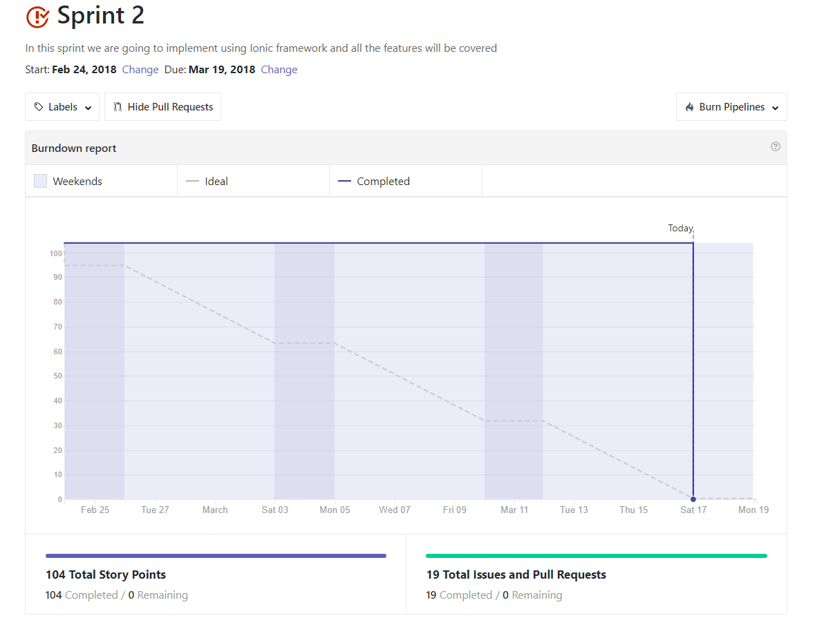

**Third Increment Report:**

**Services and API Used:**

* Yandex API for Text to Text language translation.
* Firebase for storing the details of the user and email authentication.
* Google OCR plugin for extracting text from image.
* Google maps API for maps and user location and navigation.
* Geolocation for getting the user current location.
* Clarifai for visual detection and getting insights from an image.
* Google API for text to speech of the translated text.

**Detail Design of Features:**

**Wireframes and Mockups:**

**Below are the screenshots for the wireframes and Mockups:**

1. **Login Page**

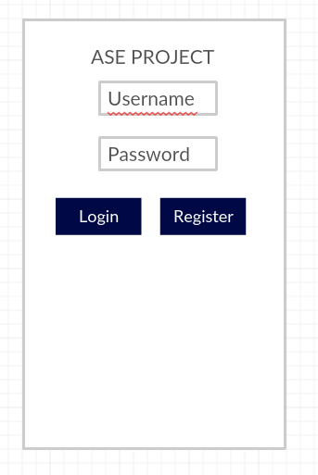

1. **Home Page**

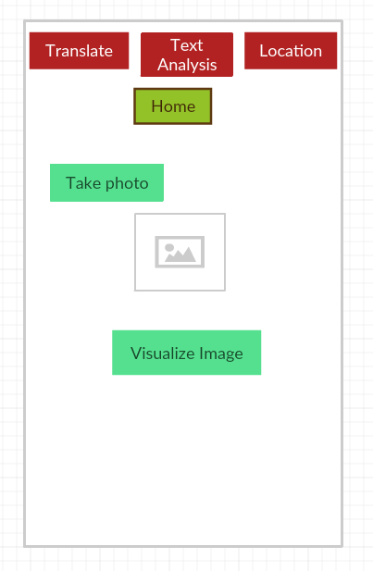

1. **OCR Plugin:**

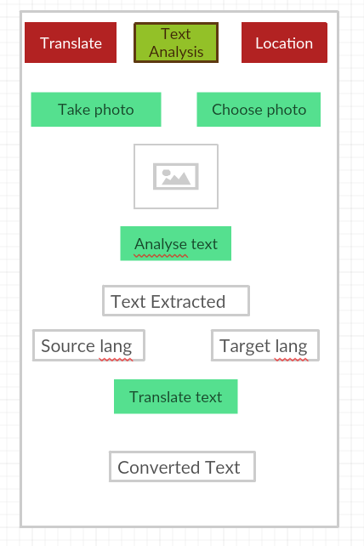

1. **Language Conversion:**

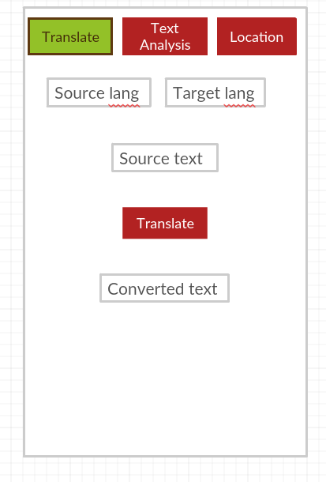

1. **Maps:**



**Architecture Diagrams:**

1. **Class Diagram:**



1. **Sequence Diagram:**



1. **Iteration-3 Architecture Diagram:**

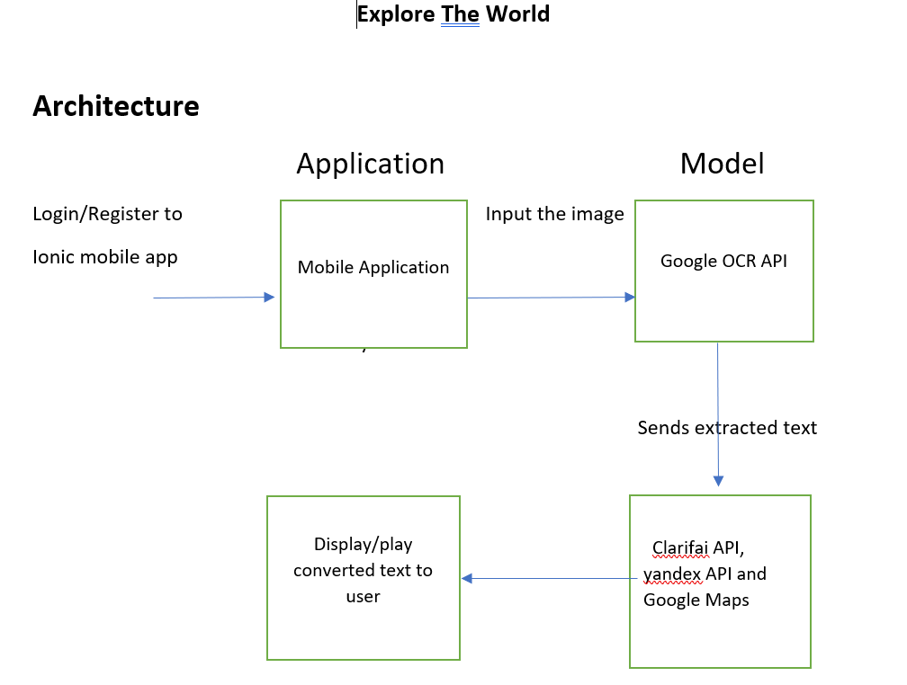

**Implementation:**

Created an application using Ionic framework so that the application is runnable in any platform and user friendly. Application has a login page where user will be able to login and use the services provided in the application and user will be able to register and the details are stored in Firebase and email authentication is used for logging into the application.

After login into the application tourist will be able to use various services like text to text translation, image prediction, Google Maps and text to speech

1. **Login Screen:**

User will be able to login into the application using email authentication provided by Firebase API.

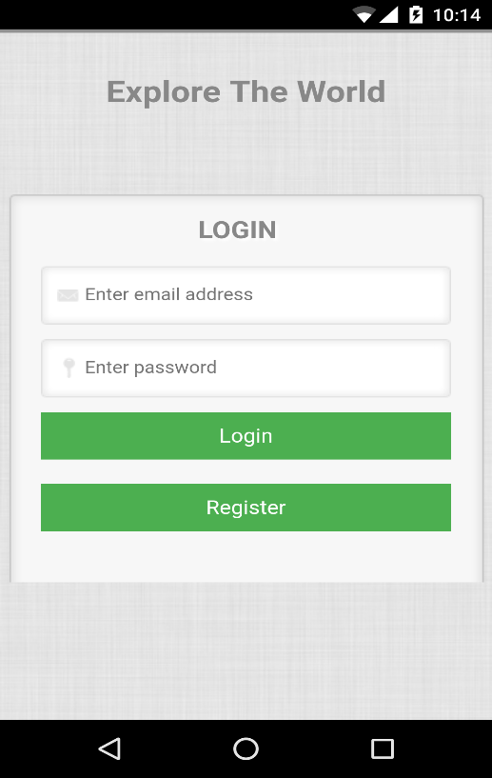

1. **Registration Screen:**

Registration of a user is done by using by the same login screen, when user provides email and password and clicks register the details will be saved in the Firebase database and the data is fetched when user logins using the email and password set at the time of registration.

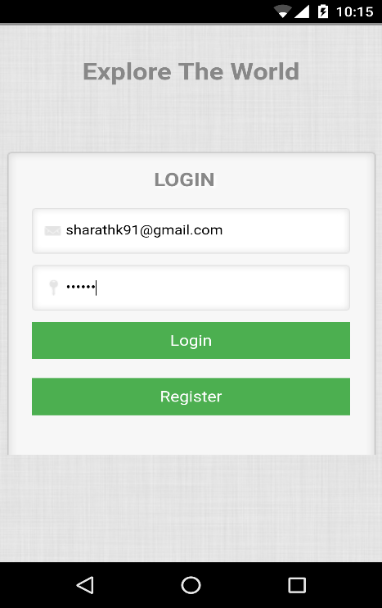 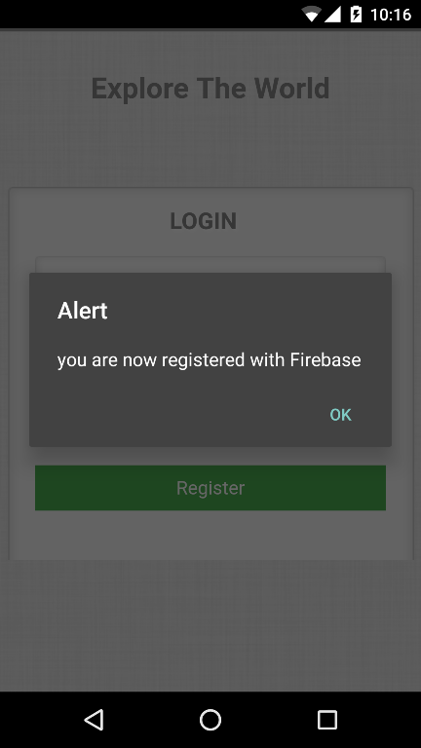

1. **Home Page:**

Home Page contains all the services of the application and tourist can use all the services that are required

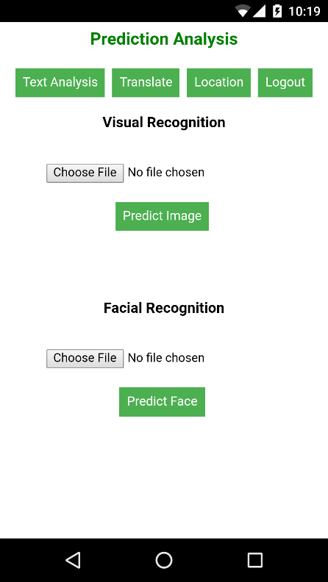

1. **Google OCR Plugin:**

OCR plugin is used to extract text from an image so that tourist can take a picture of an image and convert the text in the image to editable text. User can take a picture using camera of the device and select an existing image so that he can extract meaningful text from the image.

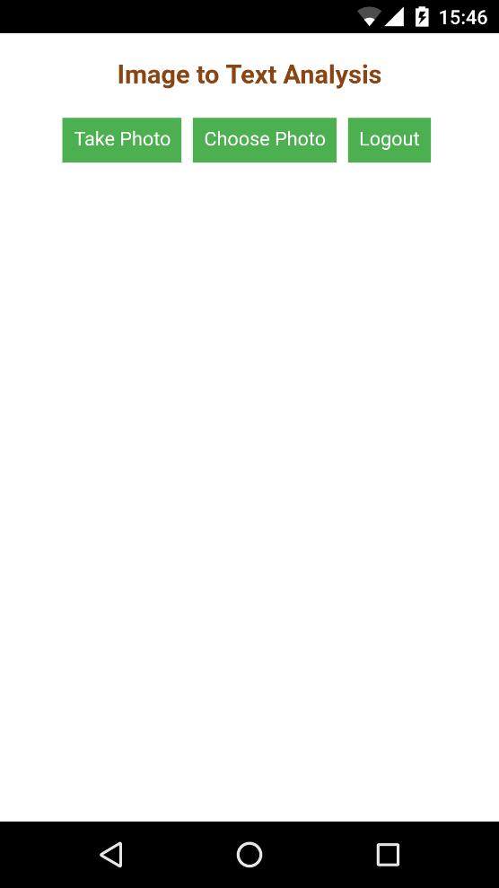 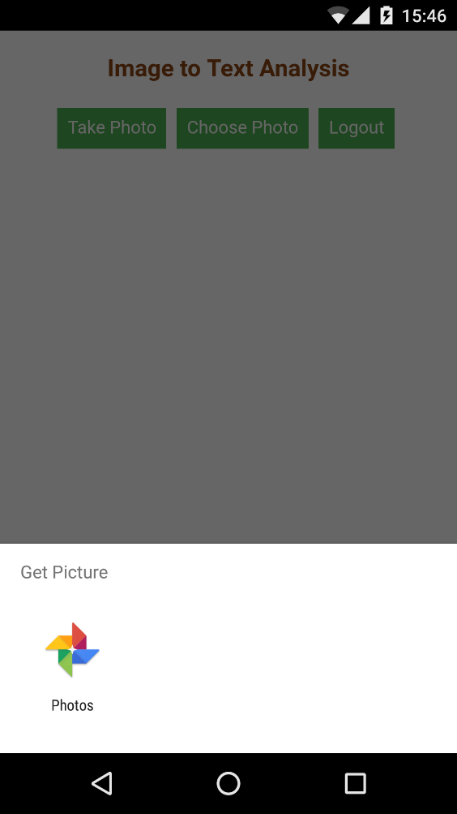

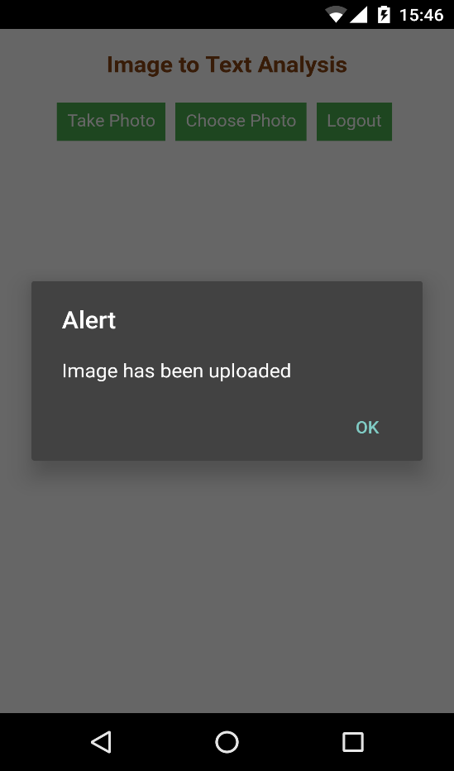 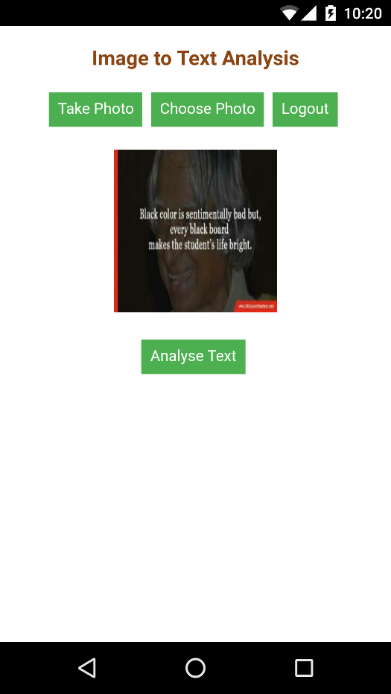

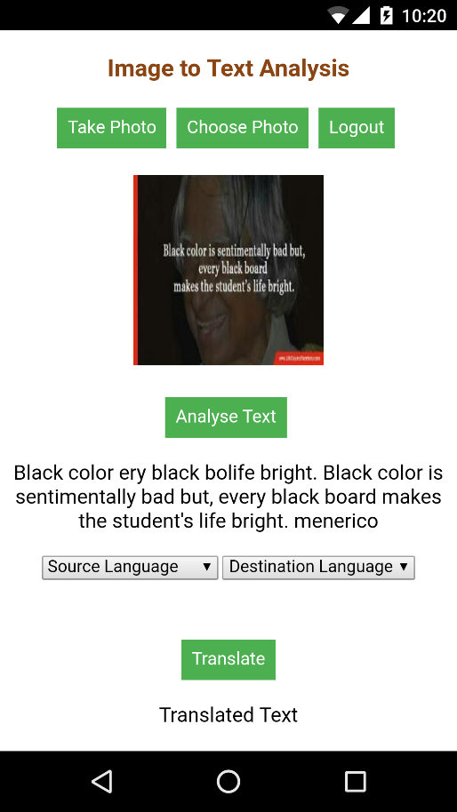 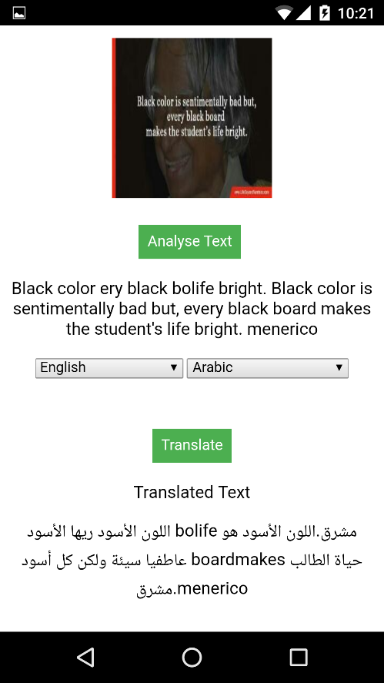

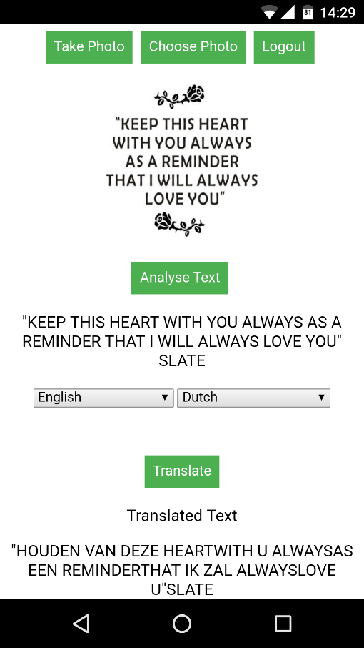

1. **Visual Recognition:**

Visual Recognition is used to get meaningful insights from an image so that tourist will be able to get useful data from an image like a traffic signal which would be useful for better understanding of various situations. User has to choose a file from the device so that he can get insights from the image.

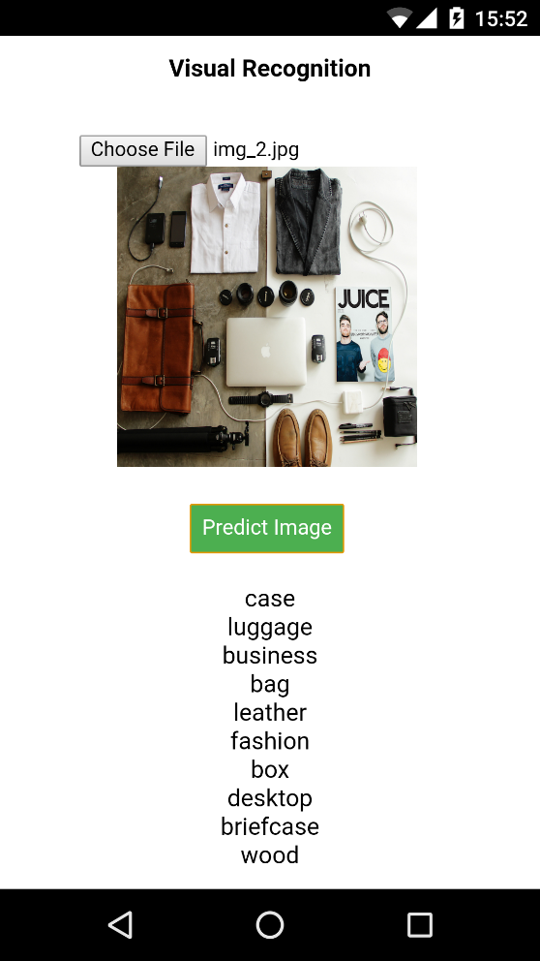 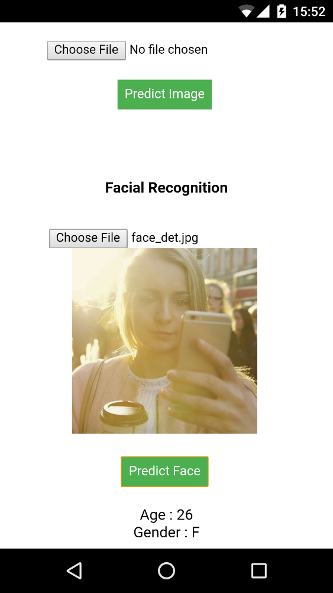

1. **Translation:**

This tab is used to translate the text from tourist native language to the preferred language so that the barrier of communication can be overcome with this service in the application.

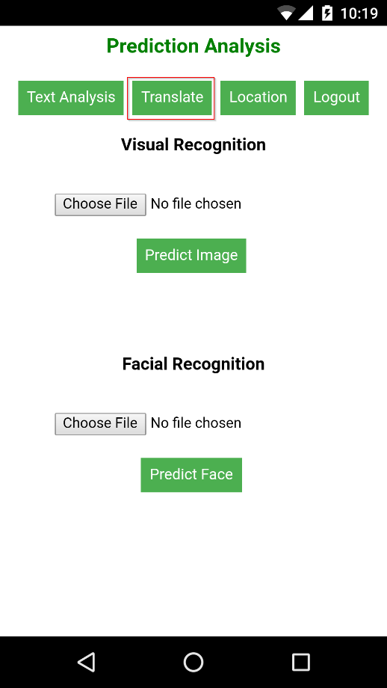 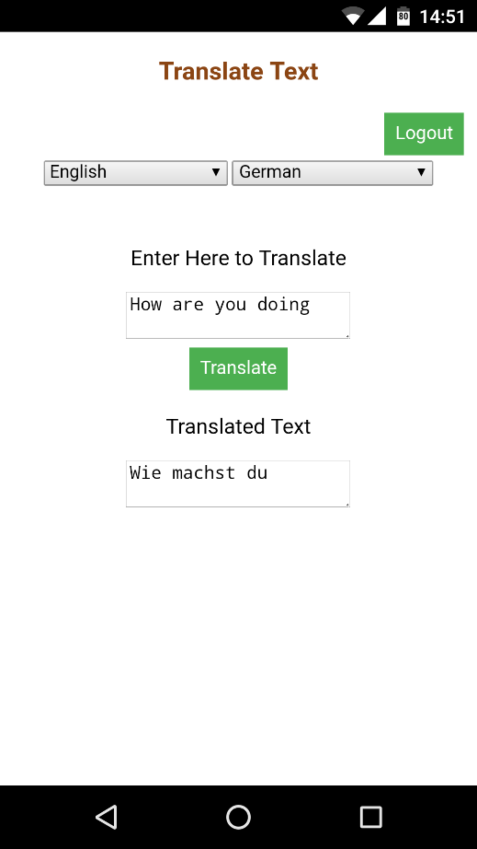

1. **Maps**

Maps is used to locate the location of the tourist so that he can find and track the movements without opening any other application for his location.

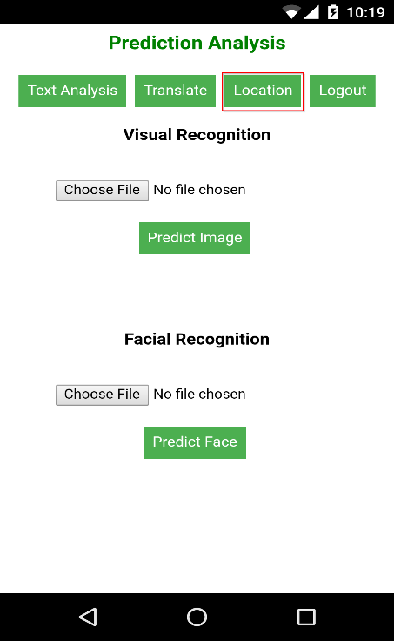 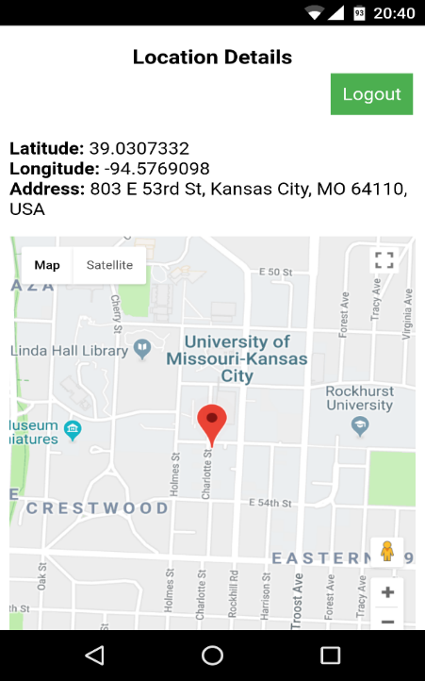

1. **Speech:**

Speech tab is used to translate the text that is translated so that the local people can understand.



**Heroku Cloud Deployment**

The project has been deployed into the Heroku cloud server

Heroku Cloud URL: [https://hidden-garden-97186.herokuapp.com/](https://hidden-garden-97186.herokuapp.com/%20)

**Augmented Reality**

Designed, Developed and implemented the Augmented Reality application with Vuforia and unity. This application will detect the sign posts and convert into the desired language. We have trained the system to detect the word “STOP” and convert into Spanish language.

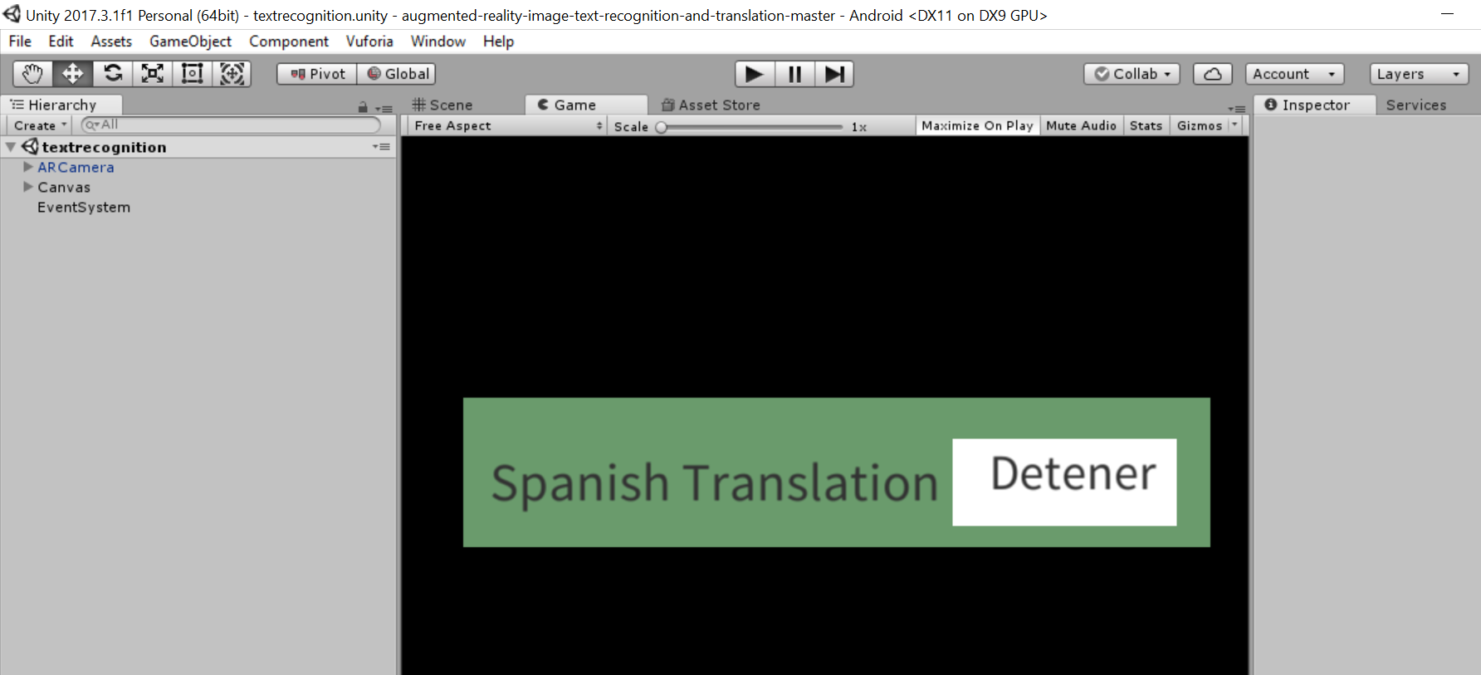

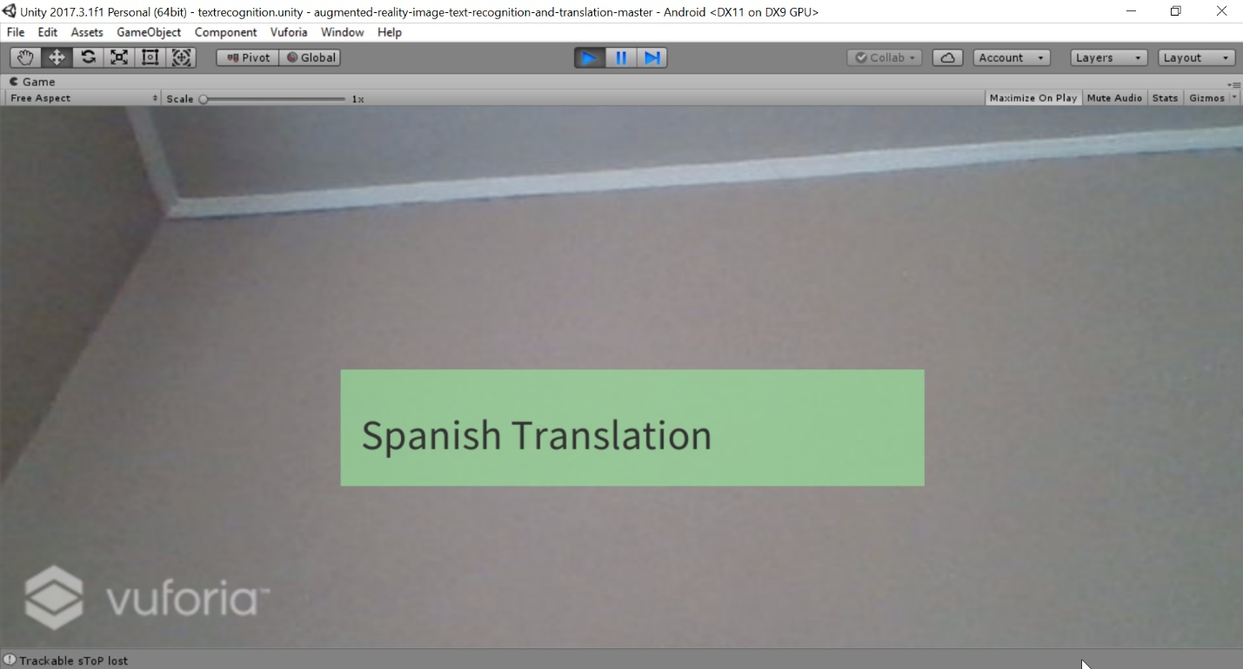

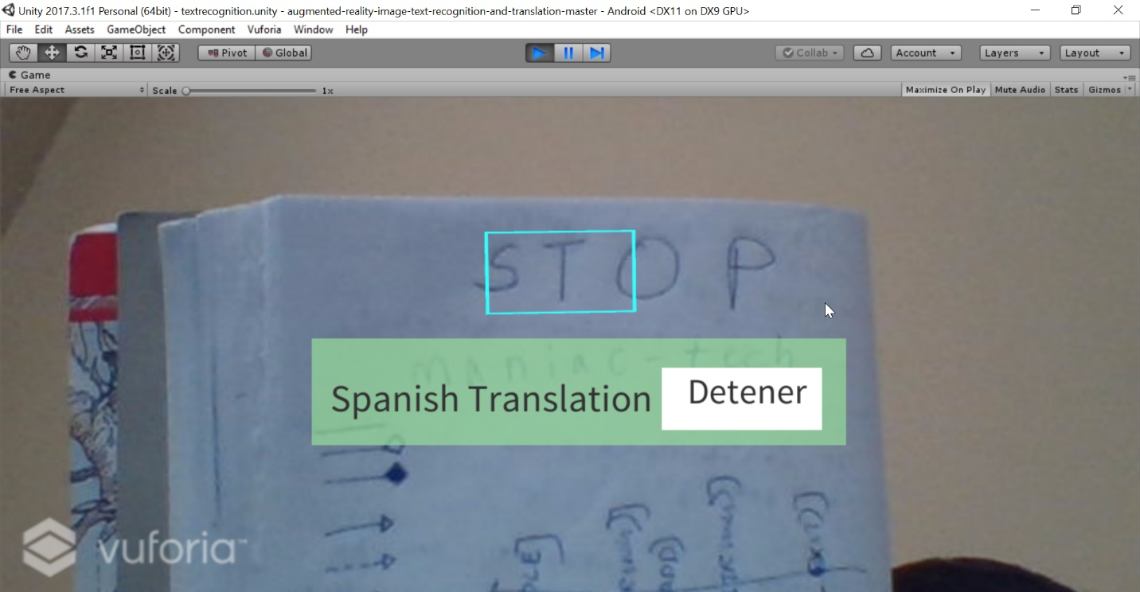

**Testing -**

**Unit Testing:** Each and every feature has been validated and is working as expected

**Performance Testing:** The performance of the entire project has been evaluated using Yslow tool which has described below

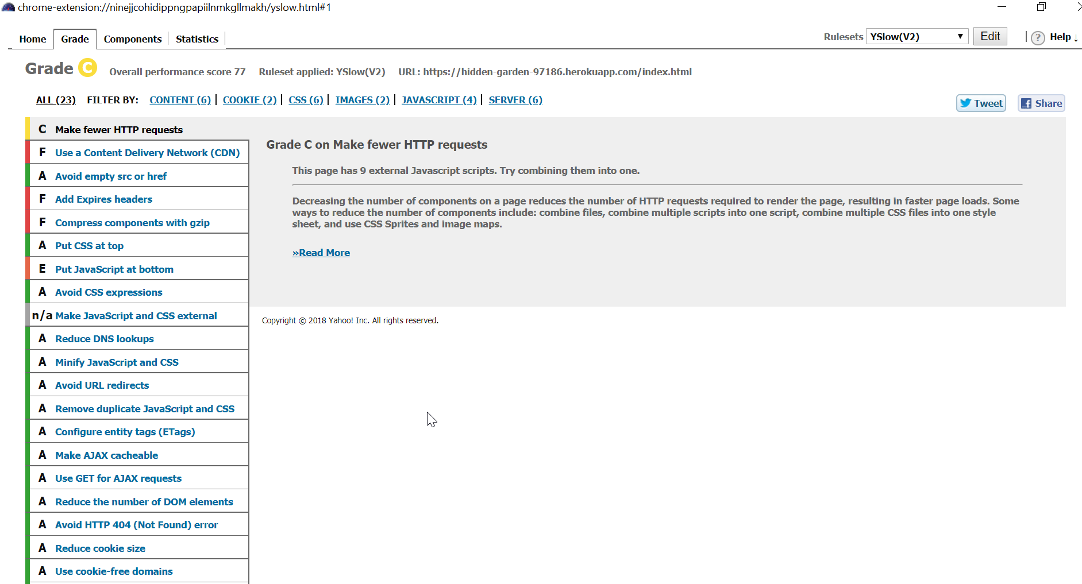

**Project Management:**

**Implementation Status Report:**

**Work Completed:**

1. **Google OCR** – In the previous iteration we have used Ionic OCR to convert image to text but due to low accuracy, in this iteration we have used Google OCR to convert images to text.

**Responsibility and Time Taken:**

* Aravind – Designed, Implemented and tested the OCR image conversion Page (24 days)

1. **Augmented Reality Application:** Developed Augmented Reality application with Vuforia and Unity. This story should be able to detect the signs and convert them into desired language.

**Responsibility and Time Taken:**

* Sharath– Design, Implementation and Testing of the translation page (24 days)

1. **Integrating Augmented Reality with Ionic** : Describes the integration of Augmented Reality Application with Ionic Framework.

* Aditya - Design, Implementation and Testing the integration of Augmented Reality (24 days)

1. **Unit & Sanity Testing:**

* Bhanu – Validated all sanity and unit test cases for the entire application (16 days)

**Concerns:** We are facing issues while integrating the Vuforia-Unity application with Ionic framework. The following are the references of Github I followed : [**https://github.com/yasirkula/UnityIonicIntegration/blob/master/README.md**](https://github.com/yasirkula/UnityIonicIntegration/blob/master/README.md)

**Future Work:** Analysing Twitter Social Media content is the pending story and will be completed in future.

**Sprint Burndown Chart:**

